FR 1-

* CLUSTER MARKET Name Alpha, Numeric, and Space not saving issue in “DISTRIBUTOR VS CLUSTER MARKET UPLOAD”.
* CM Report UI View required in CM Report Page. (Business Observation)

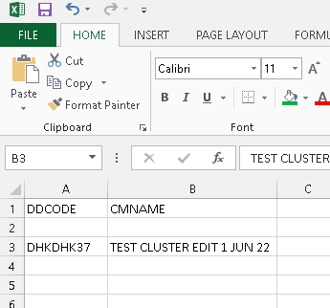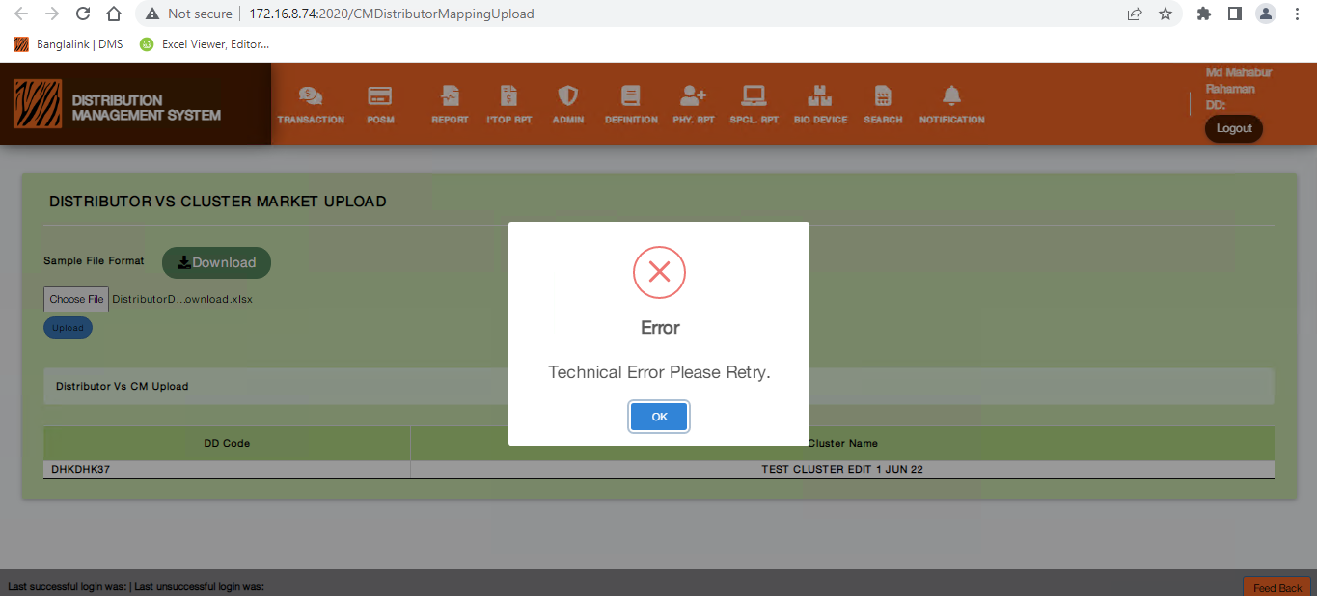

FR 3-

* Same NID, Multiple Retailers tagging issue. (Feedback from Mairaz vai)
* Error message for non-numerical number in NID Upload must be changed to “Must Be Digit” to “Must Be Numeric”.

FR 5-

* In “EV PIN RESET DETAILS” and “EV PIN RESET SUMMARY” After Selecting All in “\*Retailer” The Export Excel button doesn’t work appropriately.